This application performs the matrix multiplication using Java RMI.

-----------------------------------------------------------------------

CODE structure:

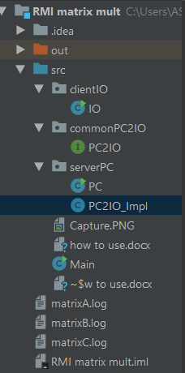

**Common PC2IO :**

public interface PC2IO extends Remote {

the interface to perform the matrix multiplication

**serverPC :**

the directory has the codes to run the server. It has 2 classes-

public class PC

and

public class PC2IO_Impl extends UnicastRemoteObject implements PC2IO

-------------------------- HOW TO RUN ----------------------

1.Initiate the RMI Registry by running Server.Server. For example:

Java Server.Server **168.18.104.181**

**Command line arguments :**

1st argument is the ip address of Server, by default it is local host,given - **168.18.104.181**

**-------------------------------------------------------------------**

2.Run IO.IO to run the client side of the RMI program. For example:

Java IO.IO **4 4** **4 4** 168.18.104.181

**Command line arguments:**

1st and 2nd argument – row and column num of matrix A – here 4 and 4

3rd and 4th argument – row and column num of matrix B – here 4 and 4

5th arg is the ip address of host server

By default it is : 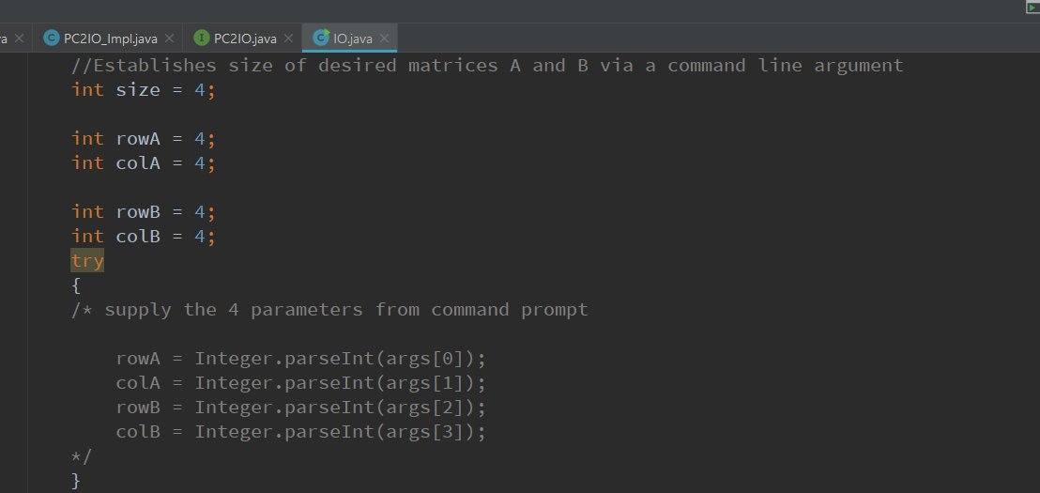

This will create matrices A and B, with a length of 4.

The randomly generated values vary between -100 and 100. Using RMI, matrix C (the product of A and B) is calculated.

Matrices A, B and C are printed and saved to a log file. The log files are :

